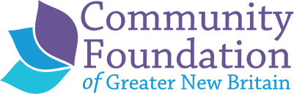

2024 Capacity Building
Workshops and Application

The Community Foundation of Greater New Britain will offer in-depth, hands-on capacity building training workshops to local non-profit organizations based in or significantly serving Berlin, New Britain, Plainville and Southington. Unless noted, all trainings will be in person. Below is a menu of this year’s offerings. All workshops are free of charge.

DIVERSY, EQUITY AND INCLUSION
Navigating the Supreme Court Decision: Empowering Nonprofits for Continued DEI Efforts
Trainer: Jenora Ledbetter, The Self Care Network, LLC
This training is 3 sessions and designed for nonprofit leaders, executives, HR professionals, and individuals responsible for DEI within their organization. By participating in this series, organizations will not only navigate the complexities of the Supreme Court decision but also proactively shape a more inclusive and equitable future and uphold the values of diversity, equity, and inclusion that lie at the heart of every nonprofit's mission. If you sign up, you are expected to attend all 3 sessions. Snow date for this session is March 12 from 9-11am if any of the sessions need to be pushed due to weather.
February 13, 9-11 am: Session 1: Understanding the Supreme Court Decision and its Implications: Participants will possess a comprehensive grasp of the background, context, and key elements of the Supreme Court decision on Affirmative Action, and a clear understanding of its potential impact on nonprofit organizations. Participants will be equipped with practical strategies and approaches to navigate potential setbacks arising from the Supreme Court decision, ensuring the continued enhancement of their diversity, equity, and inclusion (DEI) initiatives.
February 20, 9-11 am: Session 2: Adapting Nonprofit Policies and Practices for DEI Excellence: Nonprofits will have the tools to comprehensively assess their existing DEI policies and practices, identify areas for improvement, and develop a strategic roadmap to align policies with evolving legal requirements and organizational aspirations. Nonprofit organizations will gain insights into embedding DEI principles within their organizational culture by utilizing policies, training, and leadership practices. Additionally, participants will learn effective advocacy strategies to promote diversity, equity, and inclusion within their sector.
February 27, 9-11 am: Session 3: Building Collaborative Networks and Leveraging Resources: Nonprofits will be adept at building collaborative networks, engaging stakeholders, and advocating for policies that advance DEI initiatives. Furthermore, participants will acquire the skills to identify and secure funding and resources to support the longevity of their diversity, equity, and inclusion endeavors. Participants will actively apply the concepts discussed in the sessions through interactive discussions, case studies, and practical exercises, ensuring the transfer of knowledge from theory to actionable strategies within their respective organizations.

LEADERSHIP TRAINING
The Leadership Forum
Trainer: Alicia Davis, Transformative Leadership Services
The Leadership Forum™ is comprised of two full days and supports current or up and coming managers/supervisors/Executive Directors in exploring the essence of ‘who they are’ and ‘how they are being’ as a leader. Participants then take this insight and explore 'what they are doing' as a leader in terms of building relationships and communicating with others effectively. In the forum, we discuss a broad overview of leadership qualities and skills, while taking a deeper look at some of the key aspects of successful leadership. Participants are guided by certified coach trainers, and supported by peer learners, in a highly interactive learning environment. See attached flyer for more information.
Key topics included in The Leadership Forum:
Day 1: March 15 - 9am to 4pm: – (explore ‘how you are being’)
• Explore Confidence
• Define Core Values
• Lead Authentically
• Create Balance
Day 2: March 22 – 9am to 4pm: – (explore ‘what you are doing’)
• Build Trust
• Manage Conflict
• Become a ‘Coach-like’ Leader
• Create an Action Plan

Snow day in the event of cancellation: March 29 from 9am-4pm

STRESS MANAGEMENT AND WELLNESS
RISE
Trainer: Heather Labbe, certified RISE trainer, YWCA New Britain
RISE is an evidence-based program originally developed at Kripalu Center for Yoga & Health. It is designed specifically to support greater clarity and resilience, improve situational awareness, better decision making, help develop work/life integration, and create superior long-term performance for individuals and organizations. With RISE, sustainable change occurs at three levels:
- Personally - navigate stress with skill to avoid burnout
- Professionally - lay a foundation for mindful, authentic & effective leadership
- Organizationally - foster a positive culture focused on meaning, purpose and connection.
This training is for anyone at any level in your organization and will be provided in four 2-hour sessions and will be offered from 9-11am April 2, April 9, April 16 and April 23. If you sign up, you are expected to attend all four sessions. For more information on RISE content and how it works: click HERE
NON-PROFIT FINANCES – THE BASICS – May 2 from 3-6 PM
Trainer: Susan Rosati, Danosky Associates
This session will provide an understanding of a nonprofit organization’s financial activities, responsibilities and operations. It will include a primer on financial statements, how to build an annual budget and how to prepare and understand financial statements (including the statement of activities and a nonprofit balance sheet). It will review the basics of functional accounting – specifically for nonprofits and how it differs from for-profit accounting and explain how financial statements are aligned with your organization’s 990. This session is helpful for both Executive Directors, finance directors and Board members who serve on the Finance Committee.
BOARD BUILDING AND BOARD ENGAGEMENT– September 17 from 3-6pm
Trainer, Sharon Danosky, Danosky Associates
This session will focus on the Executive Directors’ role in educating, engaging and strengthening the board. While board members have specific roles and responsibilities, a skilled and knowledgeable Executive Director can help board members better understand their roles; become more active and engaged in order to help lead the organization. We will review the roles and responsibilities of Board members, the difference between governance and board development and provide skills to Executive Directors that can help forge a better partnership with their Chairs of the Board, Board Committees and others. Chairs of the Board are encouraged to attend.
FUNDRAISING FUNDAMENTALS - October 15 from 3-6pm
Trainer, John Brooks, Danosky Associates
This session will provide a deep review of how a fundraising plan is built and the role of the board in raising funds. Using the Fundraising Pyramid as a guide, it will review the need to acquire new donors, the necessity to retain those donors and how good retention can lead to major gifts. There will be discussion about the different methodology that can be used for each and how fundraising programs that thrive allocate their time to raise more money. The effective use of boards and volunteers will be demonstrated and we will discuss how Executive Directors can best encourage board participation. Board members, especially those who serve on the Development Committee and development staff are encouraged to attend.
EXECUTIVE DIRECTOR SUPPORT
In addition to the continuation of our current Executive Director peer support and networking group established in 2020 and facilitated by Sharon Danosky of Danosky Associates, we will be providing a second series in 2024 for newer Executive Directors in the Executive Director role for 5 years or less. Participants will receive nuts and bolts resources pertaining to non-profit management as well as peer support. This group will be facilitated by Alicia Davis from Transformative Leadership Services. Anyone interested in either group should contact Joeline Wruck at jwruck@cfgnb.org.
CONSULTANT SUPPORT AND MINI GRANT PROGRAM
The Community Foundation of Greater New Britain (CFGNB) Consultant Support Program will provide funding of up to $2,000 to non-profit organizations for an outside consultant, thought partner or coach to help an organization work through a challenge or explore an opportunity that will increase organizational capacity, functioning, efficiency or sustainability or to support implementation of a small capacity-building project OR for a capacity building mini grant for something that will help strengthen your organization and the Board’s capacity to operate.
Possible areas of focus include (but are not limited to) governance, succession planning, fundraising, marketing/communications, social media and website needs, technology and Diversity, Equity and Inclusion. To complete your application, you can log onto our online portal from our website on the “Applying for a grant page” or by clicking here. Use the 2024 Capacity Building Consultant or Mini Grant application form. If this is your first time using the portal, you will need to create a profile first. Feel free to contact Joeline Wruck prior to submitting you application to discuss if your project is a good fit for this program.
STAFF TRAINING PROGRAM
The Community Foundation of Greater New Britain will provide scholarships of up to $750 for a staff member in a leadership or supervisory role, including the Executive Director to participate in a workshop, class or training of their choosing that advances their work in their non-profit or that prepares them for new roles within your organization. Scholarship money of up to $1,000 can be used for an organization to bring a trainer for a group of staff. All scholarships will be provided on a first-come, first-served basis until funds allocated for 2024 are expended.
To complete your application, you can log onto our online portal from our website on the “Applying for a grant page” or by clicking here. Use the 2024 Staff Training application. If this is your first time using the portal, you will need to create a profile first. Feel free to contact Joeline Wruck prior to submitting you application to discuss the training or if you have questions.

2024 CFGNB Workshop Presenters
JOHN BROOKS, DANOSKY & ASSOCIATES
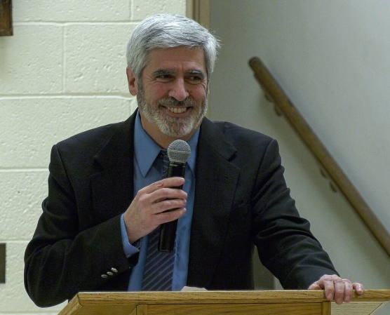
John Brooks has over 27 years of non-profit management and fundraising experience. He has expertise in major & planned giving, corporate sponsorships, foundation & corporate grants, fundraising events, direct marketing, volunteer management, community outreach, external communications, and media relations. John has extensive experience developing, training, and leading numerous volunteer and board committees to identify and solicit donors and to conduct fundraising events. John was most recently the Chief Development Officer for Columbus House, a New Haven based non-profit organization serving those who are experiencing homelessness and has served in that capacity since January 2004. Prior to working at Columbus House, he was Vice President of Marketing & Development for Save the Sound, a New Haven based environmental organization and was also Director of Development at the state headquarters of Special Olympics Connecticut.
John has been a member of the Association of Fundraising Professionals (AFP) since 1996. He has served on the AFP Board of Directors since 2006 and was the Chapter President in 2011-2012. He has held leadership positions on the Program, Nominating and Mentorship Committees. He is the 2021 AFP Outstanding Fundraising Professional. He is the former Vice Chair of the Greater New Haven Chamber of Commerce’s Non-Profit Resource Council and served on the steering committee for Leave-A-Legacy Connecticut. He is a graduate of the Greater New Haven Leadership Center.

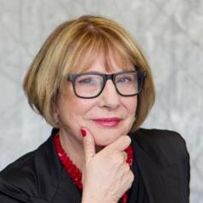

SHARON J. DANOSKY, DANOSKY
Sharon Danosky is a strategist and thought leader who partners with nonprofit organizations and their boards to build organizational capacity that works. With over 25 years as a member of the senior management team for hospitals and human organizations and over 10 years’ consulting for organizations across the non-profit sector, Sharon knows how to drive change and achieve results. As a consultant, facilitator and teacher, Sharon has led organizations to achieve unprecedented growth. She has re-infused boards with a new sense of purpose, focused discussions on strategy and impact, and facilitated collaborations among organizations for greater impact.
Sharon’s non-profit experience began by being a member of the team that raised the funds to build a new hospital, almost 40 years ago. Thus began her love of fundraising. Since then she has raised hundreds of millions dollars for health and human service organizations, libraries, animal and environmental organizations as well as arts and cultural organizations. While fundraising is where Sharon cut her teeth, as she progressed in her career she assumed responsibility and honed her skills in strategic planning, facilitating strategic alliances, governance and building board capacity and most recently in creating and nurturing diverse and inclusive boards whose work is also infused with racial equity.
Sharon is a BoardSource Certified Governance Consultant and holds a Master’s Degree in Business Administration. She has conducted rousing seminars and workshops through her affiliations with national, regional and local associations and foundations and is a trainer on the Principles of Fundraising for AFP and taught classes on Governance and Fundraising at SUNY in Purchase, NY. She is also a sought-after presenter at international conferences and has published articles on governance, boards, fundraising and strategy. She was part of a ten-member delegation that worked with non- governmental organizations in Russia.

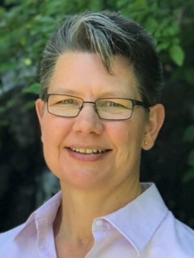ALICIA DAVIS, transformative leadership strategies
Professional Certified Coach
Energy Leadership Index™ Master Practitioner
Licensed Practitioner, Results System™
Certified Compassion Fatigue Educator
Former CT Licensed Massage Therapist
Alicia Davis is an owner/partner in Transformative Leadership Strategies. She brings over 30 years of wellbeing and leadership development experience in a variety of fields including holistic healthcare, non-profits, insurance, engineering, and corporate. Alicia creates dynamic coaching and teambuilding experiences for leaders at all levels of an organization that addresses challenges such as organizational culture, team alignment, change management, communication, and high stress.
Alicia’s clients include leaders who want to improve team performance, employee engagement, and retention; staff who want to prevent compassion fatigue and burnout and improve well-being; service providers who are looking to elevate the quality of client care; and individuals who want to create a more balanced lifestyle.
Alicia is the Secretary of the Board and Governance Chair for Community Solutions Inc., a CT-based nonprofit which creates opportunities and empowers success for youth, adults, and their families.
In addition to her multiple coaching certifications, Alicia is an internationally recognized voice through her Sound Bytes for Serenity™ CD series, contributing teacher on the meditation app Insight Timer, and a contributing author to “Strategies for Success: Your Operation Manual for Excellence.”
​

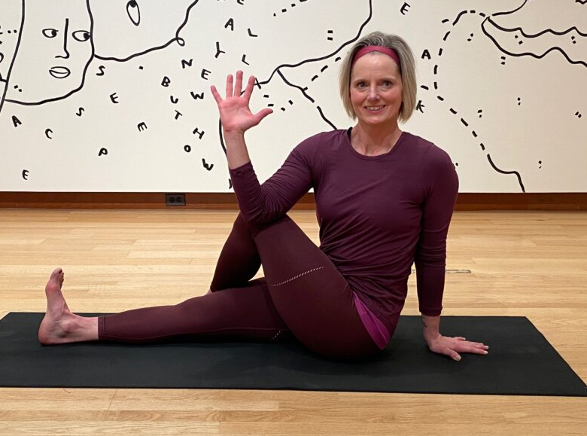
Heather Diemond Labbe is a professional health & wellness educator with over 20 years of experience facilitating live and virtual workshops for individuals and groups of up to 3000 participants. Heather is currently pursuing her master's degree in mental health at Central CT State University. Her current certifications include:
• Trauma Informed Yoga
• RISE Stress Resilience Workshop Facilitator
• Courageous Conversations Facilitator
Anchored in the science and practice of mindfulness, yoga, and positive psychology, the RISE curriculum balances practice, research, and real-world application. Published research on RISE has shown that participants sustained boost in mindfulness, empowerment, and resilience, as well as a 32% reduction in day-to-day stress levels.

JENORA LEDBETTER, THE SELF CARE NETWORK
Certifications:
- Diversity Equity Inclusion Officer via University of South Florida
- Interim CEO/Executive Director via Third Sector Company, Inc (Interim Executives Academy)
- Non Profit Management via NPT
- Employment & Labor Law via Sacred Heart University

Jenora Ledbetter created The Self Care Network LLC with the vision and drive to improve businesses and organizations focused on developing their leadership and diversity skills with experience and integrity.
​
With a master’s in child advocacy and policy and bachelor’s in psychology, Jenora is a certified Chief Diversity, Equity, and Inclusion Officer, and holds a certification in Employment & Labor Law with a focus on the legal aspects within HR Management, including discrimination laws, Family and Medical Leave Acts, drugs and alcohol in the workplace, and various labor relations laws. Jenora has over 14 years of experience helping businesses and organizations minimize the liability of discrimination in the workplace by enabling organizations and individuals to learn and grow to their fullest potential by recognizing representation gaps in their workforce and identifying fragmented leadership
​
Certified as Diversity, Equity, and Inclusion Officer from the University of South Florida Muma College of Business, Jenora has taught courses on Organizational Behavior, Leadership Management, Cross-Diversity & Inclusion, and Cultural Awareness and Sensitivity. She specializes in Diversity, Equity & Inclusion, Leadership Team Development, Executive Coaching, Board Governance, and Strategic Planning. Her passion is creating environments where individuals, teams and organizations can transform and break through to unparalleled performance.

Through experiential coaching and training models, Jenora facilitates the individual awareness and skill development necessary for effective leadership in today’s diverse world. She is a former Executive Director of several non- profit organizations where she led the departments oversight and was integral to shaping the organization’s strategic direction during a major period of transformation.

Jenora's passion is replacing image based policies with real frameworks to design new systems that are rooted in equity by building a framework for organizations to create inclusive spaces for BIPOC community. In her work with leaders, she authentically shares her personal challenges of navigating the corporate world while holding onto her authentic leadership style as a Woman of Color.
​

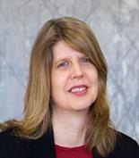
SUSAN ROSATI
Susan Rosati is a business professional with twenty years of accounting experience. Her expertise includes working in the public, private and non-profit sector. She is skilled in QuickBooks online with creating a set of books, consulting, reporting and properly maintaining records according to GAAP requirements. She is adept at working with both small start-up organizations and large established companies. Her goal is to provide the information needed to help management make smart decisions in running their organization.
At Danosky & Associates when clients need a helping hand with setting up budgets, preparing reports, evaluating financial scenarios or even prepping 990’s, Susan can step in and help. Susan can tailor their accounting system to their non-profit needs and develop a finance plan that works for all parties. This process includes properly recording revenue and expenses, weekly cash flow, timely reconciliations, budget planning, analyzing financial statements and year-end procedures. She is responsible for all financial reporting at Danosky & Associates. She holds an MBA from Marist College in Poughkeepsie and a Bachelor of Science in Marketing from Slippery Rock University while rounding out her accounting education at the University of Pittsburgh. According to Susan, there is nothing more satisfying than watching a small start-up or non-profit take off and grow over the years.

2024 CFGNB Capacity Building
Training Application
Organization:___________________________Executive Director:_____________________

Telephone:_________________Email:_______________________

If your organization is not based in our service area, what percentage are those you serve are from Berlin, New Britain, Plainville and Southington? _____
Do you have authorization from your Board to participate in this program? Y / N

Total number of paid staff: ______ Total number of volunteers: ______

Please indicate which session(s) you are signing up for and who will participate. If possible, please list specific names – we prefer not to hold spaces unless there is an extenuating circumstance. Feel free to list more than one person from your organization to attend in priority order and we will allow as space permits. Please type the information:

_____ Navigating the Supreme Court Decision: Empowering Nonprofits for Continued DEI Efforts - February 13, 20, 27 (with a snow date of 3/12)
Name, position at agency and email of those that will be attending:
_____ RISE, Stress Management and Wellness – April 2, 9, 16 and 23 from 9-11am
Name, position at agency and email of those that will be attending:
_____ Leadership Forum – March 15 and 22 from 9am-4pm (snow date of March 29)
Name, position at agency and email of those that will be attending:
_____ Non-Profit Finances – the Basics – May 2 from 3pm-6pm
Name, position at agency and email of those that will be attending:
_____ Board Governance and Board Engagement– September 17 from 3pm-6pm
Name, position at agency and email of those that will be attending:
_____Fundraising Fundamentals – October 15 from 3pm-6pm
Name, position at agency and email of those that will be attending:

Executive Director Signature:_____________________________Date:__________________
By signing I commit to:
- Attend all workshops I sign up for in their entirety (unless there is an unforeseen emergency or there is a pre-arranged agreement with CFGNB to leave early)
- Have staff attend all workshops for in their entirety (unless there is an unforeseen emergency or there is a pre-arranged agreement with CFGNB to leave early)
- Bring board members to workshops when appropriate
- Do my best to implement what I learn from the workshops to strengthen the organization
- Bring the information learned from the workshops to the Board in what is learned from the workshops
- Complete surveys sent to me by the CFGNB

Printed Name:_______________________________________

Email this application to Joeline Wruck: jwruck@cfgnb.org

APPLICATION MAY BE SUBMITTED AT ANY TIME AS SPACE PERMITS.
DEADLINE FOR PRIORITY REGISTRATION IS JANUARY 15, 2024
Questions? Contact Joeline Wruck via email or at 860-229-6018 x307

Thank you to Farmington Bank Community Foundation for supporting the CFGNB Capacity Building program for non-profit organizations
