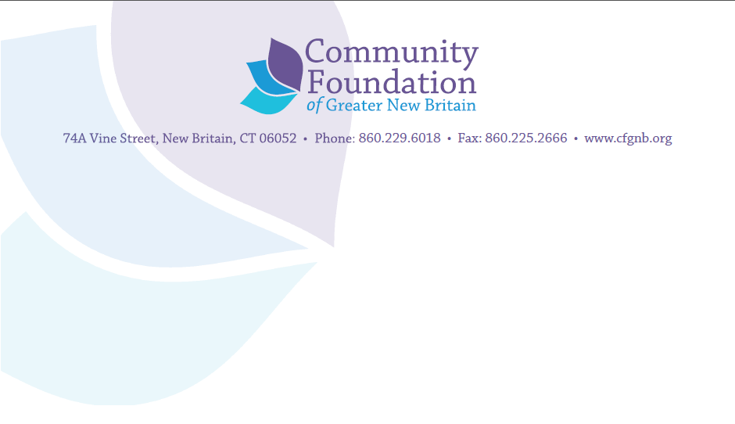

Community Investment Guidelines

The mission of the Community Foundation of Greater New Britain is to improve the quality of life in Berlin, New Britain, Plainville and Southington. One way this is accomplished is through partnerships and strategic grant making to organizations and programs that achieve clear gains for the residents of our region. We are investors focused on ensuring the greatest possible use of the money we have available. Each proposal we receive is evaluated with respect to available dollars and alignment with responses to the following questions:
- What is the expected result from the proposed grant and how will we know it has been achieved? Results are not the services or programs offered but the gains for people and conditions in our area as a result of participation.
- What are the chances that the results will happen? Our focus is on such factors as past success of program and group, key personnel leading the project, validity of approach or model, and organizational capability.
- Is this proposal a sound use of Foundation funds given other funding opportunities before us?

Type of Investments
The Community Foundation of Greater New Britain makes two types of investments from unrestricted and field of interest funds:
Improving Lives and Conditions: We invest in programs and services that improve the quality of life and promote equity for the citizens of Berlin, New Britain, Plainville and Southington.
Investing in Organizations: We invest in organizations to deliver valuable services to the community more effectively or that strengthen the ability of an organization to achieve its mission. This type of proposal might include, but is not limited to:
- Staff development – training and professional development that helps staff to deliver services more effectively.
- Strategic, fundraising or other plans and direction-setting – We support both planning and implementation of plans.
- Technology and equipment - The purchase of equipment or technology upgrades will be considered, but only as a component of a comprehensive program to move to a needed level of organizational effectiveness and efficiency.

Community Response Grants
The Foundation invests in organizations with Community Response grants across a broad range of fields including arts, culture & heritage, community and economic development, education, and health and human services. Collaborations and cooperation among local organizations for the betterment of the region are encouraged. Interest areas for Community Response grants are outlined below:
Arts, Culture & Heritage: We believe that when the Foundation supports arts, culture and heritage programs, we enhance the quality of life for all residents in those communities and invest in the long-term economic vitality and well being of the Greater New Britain area. Proposals designed to achieve the following results are encouraged:
- Strengthen the organizational capability of our area’s arts, cultural & heritage organizations in order to increase effectiveness, efficiency, sustainability and successful contributions to the economic vitality of the communities they serve
- Collaborations between or among arts organizations as well as projects/programs which promote regionalization of the arts
Community and Economic Development: We believe that supporting community and economic development as well as employment skill-building efforts adds to the strength and stability of neighborhoods and the citizens that live within them. Proposals designed to achieve the following results are encouraged:
- Address transportation issues within and between communities that improve the quality of life for citizens
- Develop both employment skills/training and the acquisition of soft and interpersonal skills needed to attain and maintain employment
- Improve the physical environment to promote civic vitality
Education: We believe that having a quality education fosters success in life. The Foundation is interested in making learning accessible to students of all ages and reducing the achievement gap. Education proposals designed to achieve the following results are encouraged:
- Foster school-community partnerships that demonstrate measurable improvement on student academic achievement, attendance, or which address summer learning loss in order to ensure student success and keep students engaged in school
- Improve literacy and language skills so individuals may become active and contributing members of their community
- School initiated enrichment programs that provide learning opportunities for youth outside of the school day. (See the “Grants for Programs in Schools” and “School System Requests” bullets under the Limitations and Restrictions section of this document for additional information.
- Provide college readiness services for those in need or workforce training for those who may not attend a two or four year university

Health and Human Services: We believe that having access to services that help maintain or improve health or which help citizens to access basic human services are fundamental to the quality of life. Proposals designed to achieve the following results are encouraged:
- Increase use and availability of resources and access to services that address basic human services that are fundamental to the quality of life
- Improve access to mental health/counseling services and create supportive communities for those facing mental health issues and their families
- Help senior citizens to maintain their independence through access to services and/or resources, transportation, education, and housing
- Address homelessness by helping those at risk to access and maintain safe and affordable housing
First Years First Early Childhood Initiative: In 2005, the CFGNB established the First Years First Initiative, a long-term investment aimed at supporting optimal learning and development of children birth through preschool so they enter kindergarten ready to learn successfully. We will consider proposals that address the following strategies we have adopted to meet this goal:
- Social Emotional Learning (SEL) among young children to support school readiness and academic success and outcomes. Provide SEL training and support for parents/caregivers teachers and other adults that work with young children
- Strengthen Parent/Caregiver Education by Building skills, knowledge and relationships in one or more of the following ways: 1) increase knowledge of child development, early brain development and the lasting impact of high quality early childhood education, 2) support deepening relationships among caregivers, educators and young children that increases and incorporates Social Emotional Learning, 3) strengthen parenting and caregiver skills so that children are supported and ready to learn and succeed in school.
- Skill Development in math, writing, and literacy young children and families.
Eligibility
We make grants to non-profit organizations that have tax-exempt status under Section 501(c)(3) of the IRS Code or that are a qualified entity eligible to receive grants from community foundations under the IRS Code. We will consider funding a grassroots group, if it has a governing body and a fiscal agent with the appropriate tax status.
Grant Size
Typically, grants range between $5,000 and $25,000 per year. However, grant awards vary depending on the scope and type of project. Assembling a project plan that includes other partners is strongly encouraged.

Duration of Grants
In general, Foundation grants are one year in duration; multi-year grants may be considered.
A one-year hiatus is required of a grantee agency after it has received three successive years of grant awards for any project from the Foundation’s discretionary funds, This policy does not apply to organizations that receive funding through a Foundation initiative. Additional exemptions will be treated on a case-by-case basis.
Application Process
The process for all requests to the Foundation begins with a Letter of Intent, available on the Foundation’s website. If you wish to discuss your proposal before submitting your Letter of Intent, please feel free to contact Joeline Wruck, Director of Community Initiatives & Program Service at 860-229-6018 x307 or email jwruck@cfgnb.org. Once your Letter of Intent is received, it will be reviewed by staff and you will be contacted regarding submission of a full application.
Grant Deadlines
Grants are made two times per year: in the spring and fall. Grant deadlines for these cycles will be February 1 and August 1.
How Grant Decisions Are Made
Each proposal is evaluated with respect to available dollars and alignment with our investor questions outlined on page 1 of this document. During the review process, staff will initiate contact with an organization if additional information is needed or if a conference or site visit is requested. Final grant decisions are made by the Board of Directors. Applicants will be notified by mail of grant decisions.
Limitations and Restrictions
- Geographic area: Community Foundation grants are available to nonprofit organizations that provide services in Berlin, New Britain, Plainville and Southington. Organizations that seek funding to provide services in these four communities but which are headquartered elsewhere must both a) collaborate with local agencies in program delivery and b) have a local partner in submitting the application.
- Operating Grants: The Foundation may invest in an organization with an operating grant to strengthen an organization and/or make possible an expansion of the critical services it provides. Organizations selected for this type of grant must have a strong track record, be financially stable and improve the quality of life in Berlin, New Britain, Plainville and/or Southington.
- Capital Grants: As an investor, we view every capital grant application in terms of the ways in which the improvement sought can enhance the ability to achieve stronger results for the population served. We are, therefore, less focused on the new or revamped space to be created or the new computers or van to be purchased. They are the means, not the end. We want to know how they will be used to increase efficiency or effectiveness in the organization. Additional guidelines for capital campaign requests are as follows:
- Capital campaign requests will be considered once an agency has reached 75% of its funding goal in gifts and pledges, so as to assure the project’s initial planning & funding assumptions are substantially met;
- CFGNB prefers that if capital campaign grants are awarded, they be made on a “Challenge Match” basis to ensure that our funding leverages other dollars needed;
- In general, capital campaign grants will not exceed our history of funding at the level of up to $50,000. Exceptions to that level may be reviewed on a case-by-case basis with regard to the size, scope and overall community benefit of the project;
- Grants will be paid once matching and/or other conditions are met and confirmation is received that work has begun and the proposed capital project is underway.
- Grants for programs in the schools: Requests from organizations seeking to provide services in a public school setting will be considered if the proposed program enhances or directly benefits a specific aspect of the curriculum or if it is directly related to the school improvement plan. A letter confirming that the project is a priority for the district and that public funds will be sought to continue the program once the Foundation grant is complete should be submitted and signed by the Superintendent.
- School system requests: Requests that come directly from schools must be approved and signed by the Superintendent. Any program funded by the CFGNB that serves an individual school as a successful pilot project should, if possible or applicable, be duplicated in other schools in the system.
- Multi-department/branch grantees: Large organizations with many branches or departments (e.g. universities, hospitals, libraries) must submit requests from the office of the President, Executive Director, or other authorized officials based on the policies of the organization.
- New submissions by previous grantees: Generally, any organization that has previously been awarded a grant is not eligible to submit another proposal as long as funds remain unspent from that previous grant or if required reports have not been submitted.
- Multiple or repeat submissions: Each organization is limited to one grant proposal for consideration during a single grant cycle. If a proposal does not receive funding, it cannot be resubmitted for future consideration, except by invitation.

Generally, the Foundation does not make grants for*:
- Sectarian or religion-based activities
- Previously incurred expenses
- Annual or endowment campaigns
- Performances or one-time events
- Conferences
- Advertising
- Political activities
- Direct support of individuals
- Camperships or scholarships for academic or enrichment programs
*Exceptions may be considered on a case by case basis

Funding Considerations
- Community partnerships and collaborations: The Foundation is interested in supporting collaboration and cooperation among local organizations for the betterment of the region. Therefore, projects or programs that involve more than one organization or town are encouraged.
- Leveraging Foundation support: Grant proposals that leverage foundation support and exhibit diversification of funding sources are more likely to receive funding.
- Program budgets that are detailed and comprehensive are vital to any program planning and should underlie any request.
- Sustainability: Projects with a realistic sustainability plan for continuation beyond the grant period are more likely to receive funding. The financial health of the application agency will also be considered.

2/1/2008, rev. 1/1/2011, rev. 12/11/2013, rev. 3/1/2018, rev. 6/16/2023

