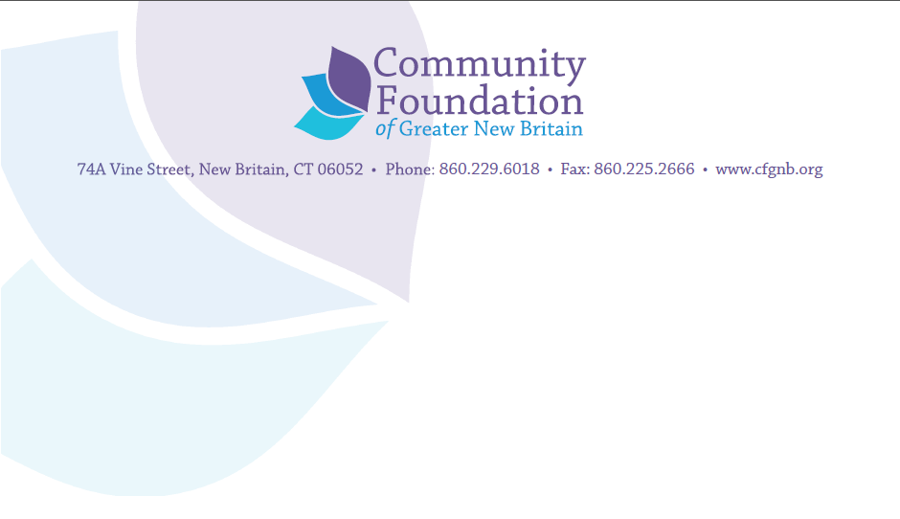

PROPOSAL WRITING SCHOLARSHIP APPLICATION
The CFGNB will provide scholarships of up to $250 for 20 non-profit organizations based in New Britain, Berlin, Plainville or Southington. We will award scholarships on a first come, first served basis and will add you to the list of potential recipients in the order that we receive this application, along with proof of payment. If it is not possible to send proof of payment with your application (because registration for your training is not yet open), please note that when you send in your application and plan to provide proof of payment later. You will still be added to the list in the order applications are received.
If you have any questions, email jwruck@gmail.com or call at 860.229.6018 ext. 307.
Organization_______________________
Name/Title of person that will participate in the training___________________________________
Phone/Email ________________________________________Date of Training________________
Tell us which training you plan to participate complete:
The Grantsmanship Center___
Candid Proposal Writing Boot camp ___
National Funding Foundation training ___
Other training: (please give us the name and website of the training you have chosen)
_____________________________________________________________________________
Please provide proof of payment with this application. If registration has not yet opened up, please tell us when that will be completed.______________________

Signature of participant (type your name) ________________________________ Date: ___________
By typing my name above, I agree to participate fully in all training dates and participate to the best of my ability.

