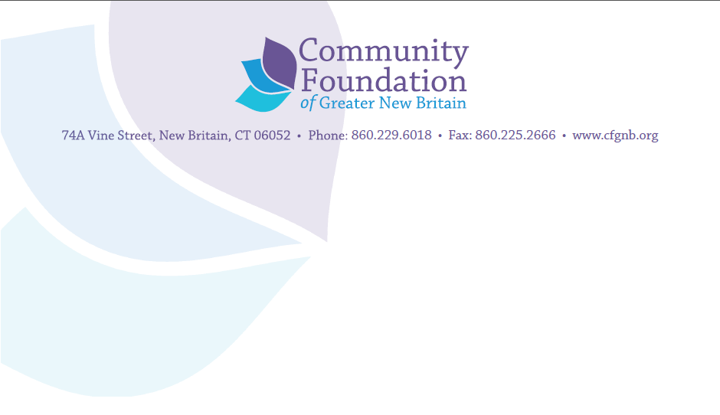

Capacity Building Training
Fundraising that Meets This Moment and the Next
As part of the CFGNB 2021Capacity Building program, Danosky & Associates will provide “Fundraising that Meets This Moment and the Next,” a two-session Fundraising workshop scheduled for March 25th and April 7 from 8:30 to 10:30 a.m. Each virtual session will include opportunities for discussion, case studies to explore and ways to keep the participants fully engaged during the training process. Presenters will be available via phone and e-mail to answer questions or to discuss concerns specific to the subject matter of the workshop for one month following each workshop.
Session 1: Donor-Centered Fundraising: What is it and how do you pivot?
Thursday March 25, 8:30-10:30 a.m.
The first session will walk through how to pivot to a donor-centered fundraising model. Sharon Danosky will teach the basics of how to qualify and cultivate donors, how to ask for the gift and how to put sound stewardship practices into place. The session will also explore how to maximize the 80/20 rule (80% of your money comes from 20% of your donors) to raise more funds. Participants will be asked to do some advance work prior to this training session, which will include looking at their major donors, mid-level donors and retention rates. Explanations of how to prepare the advance work will be provided.
To register for this workshop, click here: https://us02web.zoom.us/webinar/register/WN_-7dGRPEdTY23lO_-8OZaFA

Session 2: Mission-Based Sponsorships
Wednesday, April 7, 8:30-10:30 a.m.
The second session will demonstrate how to pivot from event-based sponsorships to inviting businesses and corporations to sponsor programs synonymous with your mission. This program will provide examples of how successfully this is working, donor responses to a new approach and hands on training on how you can apply it to your own organization. The principles learned in the first session will also be applied in this session.
To register for this workshop, click here: https://us02web.zoom.us/webinar/register/WN_fnTGbDKBRma0ODCRRCg3rQ

