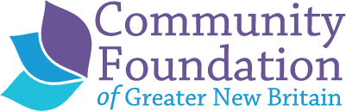

Application date: ____________
Event Specifics:

- Name and address of the organization organizing the event/program:
- Name, email, and phone for contact person:
- Name of event/program:
- Location of event/program (event must serve our 4-town area):
- Date and time of the event/program:
- Brief description of event/ program:

Budget Information:
- Amount of Community Sponsorship Award requested: $_____
- Has the Community Foundation sponsored this event before? If so, how many times?
- If you have sponsorship levels, please include them.
- Deadline date for securing sponsors:
- Please attach the budget for the event.

Advertising and Visibility:

- Who is your primary audience? How many people do you expect to attend?
- How do you plan to advertise or market your event or program?
- This is a:
☐ One time event
☐ Annual event. If so, please indicate how many years running: ______
☐ Recurring event, not annual – indicate how often: ______
- How would the sponsorship be recognized? (Please elaborate on any of the below as needed)
☐ Community Foundation of Greater New Britain (CFGNB) logo in printed program (please describe placement)
☐ CFGNB logo in paid advertising
☐ CFGNB logo in promotional materials (posters, brochure, flyers, postcards)
☐ CFGNB banner at event
☐ CFGNB speaker at event
☐ CFGNB logo on your website publicizing the event
☐ Other (Please describe)

For more information or to submit your application, e-mail CTabone@cfgnb.org or Bob@cfgnb.org.

