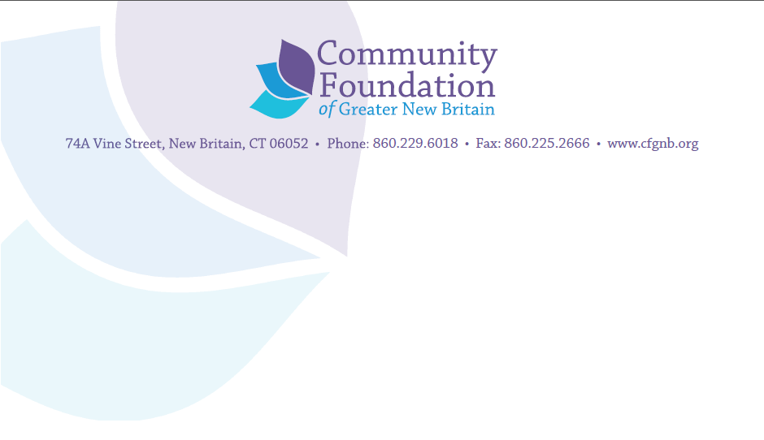

Grant Application Guidelines
The program staff of the Community Foundation of Greater New Britain looks forward to working with you. This form is for organizations that have submitted a Letter of Intent to us and were invited by the Foundation to submit a grant application.
For Community Response grants, three copies of the proposal narrative must be submitted containing all required information; we also ask that you email a copy of all materials to Kaylah Smith, Program & Scholarship Associate, at ksmith@cfgnb.org. Applications for funding through our First Years First Early Childhood Initiative should be sent to Joeline Wruck, Director of Community Initiatives, at jwruck@cfgnb.org. The proposal must be signed by the Executive Director or CEO.
Proposal Format:
- 8½x11-inch paper preferably printed on one side and stapled; pages should be numbered
- Font: Times New Roman 12pt font required
- DO NOT send videotapes, computer disks, binders or other bulky materials. Please do not send your proposal in notebooks, folders or binders
- DO NOT include information that is not requested
- The Foundation will not consider program proposals following the Common Grant Application Form developed by the Connecticut Council for Philanthropy. Instead, compile your proposal in this order:
  - Section 1: Cover Sheet
  - Section 2: Project Proposal (see content description/narrative)
  - Section 3: Key People and Groups (see content description/narrative)
  - Section 4: Financial Information (see content description/narrative)
  - Section 5: Additional Material (see content description/narrative)

Content Description/Narrative
Section 1: COVER SHEET: Your proposal should include a cover sheet with contact name for the proposal, phone number and email address, organization name and address, amount requested and the purpose of your organization.
Section 2: PROJECT PROPOSAL NARRATIVE: Please provide clear and concise answers for your proposal type (choose 1 of 3 outlined below). Your narrative should be no more than five pages; please number the pages.
Grant Type A: Program or Project Proposals
- What is the mission of your organization?
- In the past three years, what tangible results has your organization achieved for the people you serve? By results we mean not your activities or services, but what people gain from them.
- What is your project? Define in summary form what you plan to undertake. What problem or opportunity are you addressing and how many individuals within your service area covered by the Foundation (Berlin, New Britain, Plainville and Southington) are affected by it?
- Who are your participants? What are their characteristics and are they in any way different from the full set of people who have the problem within your geographic focus.
- What results are you committed to achieving? Please be very specific about the level of change that will constitute success.
- What method or approach will you use to achieve these results?
- Why did you choose this approach and what evidence supports using it?
- Halfway through your program, what predictive factors will you look for to tell you that you are on course to achieve your results with the time and money remaining? Please focus on the progress or the gain that your participants are actually making rather than your work plan.
- Will the use of our funds create an ongoing additional expense of any kind in your organization? If so, what is the nature and the amount of that expense and how will you cover it long term?
- What are the key factors that will make your program sustainable over time?

Grant Type B: Capacity Building Proposals
We choose to invest in the infrastructure of organizations that deliver valuable services to the community. An attractive candidate for this type of investment is a group that shows long term, high promise where enhanced capacity and sustainability will create increased human gain. Proposals should focus on the needs of the organization that will strengthen its ability to achieve its mission. Please provide concise and clear answers to the following questions:
- What is the mission of your organization?
- In the past three years, what results have you achieved for the people you serve? By results we mean not your activities or services, but what people gain from them.
- Describe the challenge or opportunity you face that, if addressed, would have a clear impact on the gains you achieve for those you serve.
- What is your project? Please define in summary form what you plan to undertake.
- What will you be able to achieve with this new capacity that you cannot achieve now?
- What are the results you commit to achieving with this new capacity (e.g., reducing time and costs, increasing revenue, increasing the gains from your program and/or the persons who get them or decreasing tome to achieve gains)?
- Define the 4-5 most critical steps to building this new capacity and describe what must be achieved at each step to reach the desired result.
- Halfway through your project, what predictive factors will you look for to tell you that you are on course to achieve your results with the time and money remaining?
- Describe the changes that will be needed for the new capacity to be successfully implemented (e.g., organizational changes in policies and practices). Will it require any adjustments in program or staffing to be fully successful? If so, please detail these changes and note commitments made to make them.
- If the new capacity is dependent on either a new staff person or consultant, please define the roles and results needed from each and attach a job description.
- To the extent the new capacity brings net increase in operating costs, how will you pay for them?
Grant Proposal C: Capital Grant Proposals
The Foundation will consider funding capital campaigns or building renovations. A capital request is a proposal for funds to construct a new facility, renovate or add to your current facility, or purchase and/or renovate another existing facility for use by your organization. Requests to support the purchase of general equipment also fall into this category. As an investor, we view every capital grant application in terms of the ways in which the improvement you seek can enhance your ability to achieve stronger results for those you serve. We want to know how the improvement will be used to increase efficiency or effectiveness in your organization. Please provide concise and clear answers to the following questions:
- What is the capital improvement you want to make? (Be specific in such terms as kinds of equipment, square feet of space, etc. Please do not send blueprints or specifications. We will ask for detail when needed.)
- What are the results you commit to achieving with this improvement in place? Please specifically detail the ways in which the improvement makes you more efficient (e.g., reducing time and costs) and/or effective (increasing the gains from your program and/or the persons who get them.)
- What steps have you taken to insure that the improvement is high quality and being acquired at the best possible cost? List all cost savings over a conventional “retail” cost that you have realized. Please include a brief description of your bidding process; we may ask to see bids.
- What are the implications of this improvement on operational revenues and costs? If the improvement creates higher new costs than new revenues, how will you pay for them?
- What is your long-term plan for financially maintaining the new space or improvements?
- Will the new space require any adjustments in program or staffing to be fully successful? If so, please detail these changes and note commitments made to make them.
Section 3: KEY PEOPLE AND GROUPS
- Who are the key personnel that will lead the project? Please include information on their background and experience that most predict their ability to achieve the stated results.
- For capital construction projects, who in the organization is most directly responsible for making building construction decisions and controlling costs associated with them? Please name the person and indicate what previous success in this area or personal qualifications or attributes best predict they can do it. (If key personnel have not yet been hired, please provide a job description.)
- Who are the key people who deliver the service and what factors most suggest that they can help people get the intended results?
- Is your program dependent on any partners or intermediary groups? If so, who are they, what must they do, and what assurance do you have that they will do it?

Section 4: FINANCIAL INFORMATION
- Please complete and submit the Grant Request Budget as well as the Organizational Budget for Grant Application. These documents can be downloaded from www.cfgnb.org/receiving/grants/applying-for-a-grant/.

- Please document the status of other sources of funds being pursued in support of the project. List the name of the entity, classification (government, foundation, corporate, individual, special event, or other) and amount. Indicate whether the funding request is pending, or has been declined, approved, or received.
- Unless this is a one-time expense, please provide us with a specific plan for continuing the project or program once the grant ends.
Section 5: ADDITIONAL MATERIAL:
For all proposals, please submit these additional attachments with your application:
- IRS Determination letter;
- Board of Directors list with addresses and affiliations;
- Most recently completed audit (or most recent 990 if your organization does not complete an outside audit);
- Signed Certificate of Non-Discrimination (attached)

COMMUNITY FOUNDATION OF GREATER NEW BRITAIN

CERTIFICATE OF NON-DISCRIMINATION*

The governing board of _____________________________________________
maintains the following policy of non-discrimination:
- No person is excluded from agency programs or benefits because of race, color, religion, gender, national origin, ancestry, age, medical condition, disability, veteran status, marital status, sexual orientation or any other characteristic protected by law.
- There is no discrimination on the basis of race, color, religion, gender, national origin, ancestry, age, medical condition, disability, veteran status, marital status, sexual orientation or any other characteristic protected by law with regard to hiring, assignment, promotion or other conditions of staff employment.
- There is no discrimination on the basis of race, color, religion, gender, national origin, ancestry, age, medical condition, disability, veteran status, marital status, sexual orientation or any other characteristic protected by law on the agency’s governing body.
I certify that the practices of this organization conform to the policy of non-discrimination stated above.

_______________________________________________ _________________________
Typed or printed name of President or Board Chairperson Date

_______________________________________________
Signature of President or Authorized Official

*The Community Foundation of Greater New Britain will not knowingly support organizations, projects and programs that discriminate in their employment practices or delivery of programs or services on the basis of race, color, religion, gender, national origin, ancestry, age, medical condition, disability, veteran status, marital status, sexual orientation or any other characteristic protected by law. We therefore require that all grant applicants submit a signed Certificate of Non-Discrimination confirming compliance with all applicable local, state and federal anti-discrimination laws.

