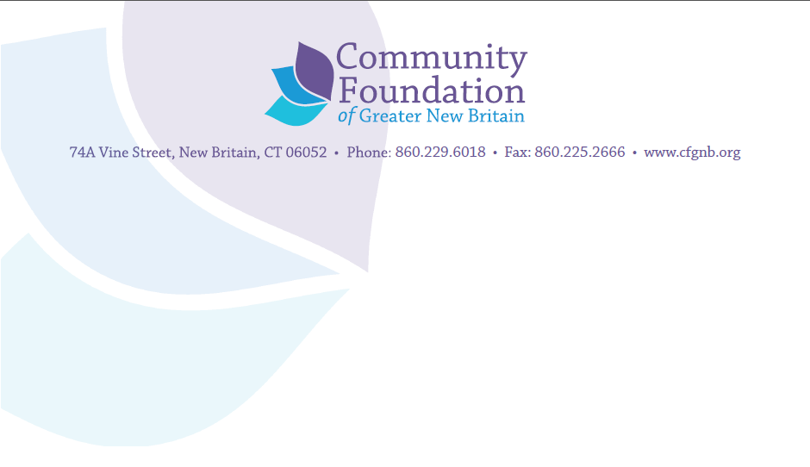

Community Foundation of Greater New Britain
Interim Report Guidelines
Program and Operating Grants
Agency Name: ____________________________Date__________________
Person Submitting the Report: ______________Phone ___________Email:_________
Name of the project funded: _________________________ Grant Amount: __________
1. Please state the results you planned to achieve with this project
2. At present, are you on course to achieve your stated result with the time and money remaining in this project?
_____yes _____ no _____unsure
If yes; please list concrete evidence to support your assessment, including progress made on the outcomes you stated in the original application that would be achieved during the grant period.
If no; please list what hindered the project and the changes you will make or solutions you will implement to get back on track.
If unsure; please list and explain the obstacles to be overcome or changes/adjustments that need to be made to ensure successful completion of the project.
3. Are those you are actually serving so far different in a significant way from those you said you would be serving in your proposal? If so, what is the difference?
4. Please demonstrate your progress on program sustainability beyond the grant period per your original proposal.
5. Please note here the amount you have actually spent as of this interim report.

