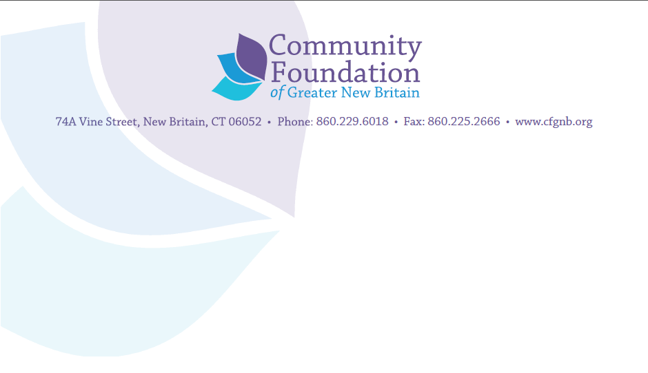

Community Foundation of Greater New Britain
Final Report Guidelines
Agency Name: ____________________________Date________________
Person Submitting the Report: ______________Phone ___________Email:_________
Name of the project funded: _________________________ Grant Amount: __________
- Please restate the expected results that were outlined in your original proposal.
2. Did you achieve these results?
_____yes _____somewhat _____no
Please indicate the evidence you used to verify your degree of accomplishment.
If somewhat or no, please explain why that occurred. We encourage you to look at what you could have done differently as well as to cite external factors that may have played a role.
3. For capacity building grants: what can you achieve with your new capacity that you could not achieve before?
4. Were there additional results or broader gains you achieved beyond those originally stated? If so, what were they and what evidence did you use to verify them?
5. Please name up to five things you are doing differently given the experience of this project. For each, please note how they are affecting your ability to get more results with the money available.
6. Briefly describe your next steps for this project (continuation, expansion, replication or termination).
7. Please include a financial report indicating your expenditures for the grant period.
8. Please enclose copies of any evaluations used to measure your results and a compilation of survey/evaluation responses.

